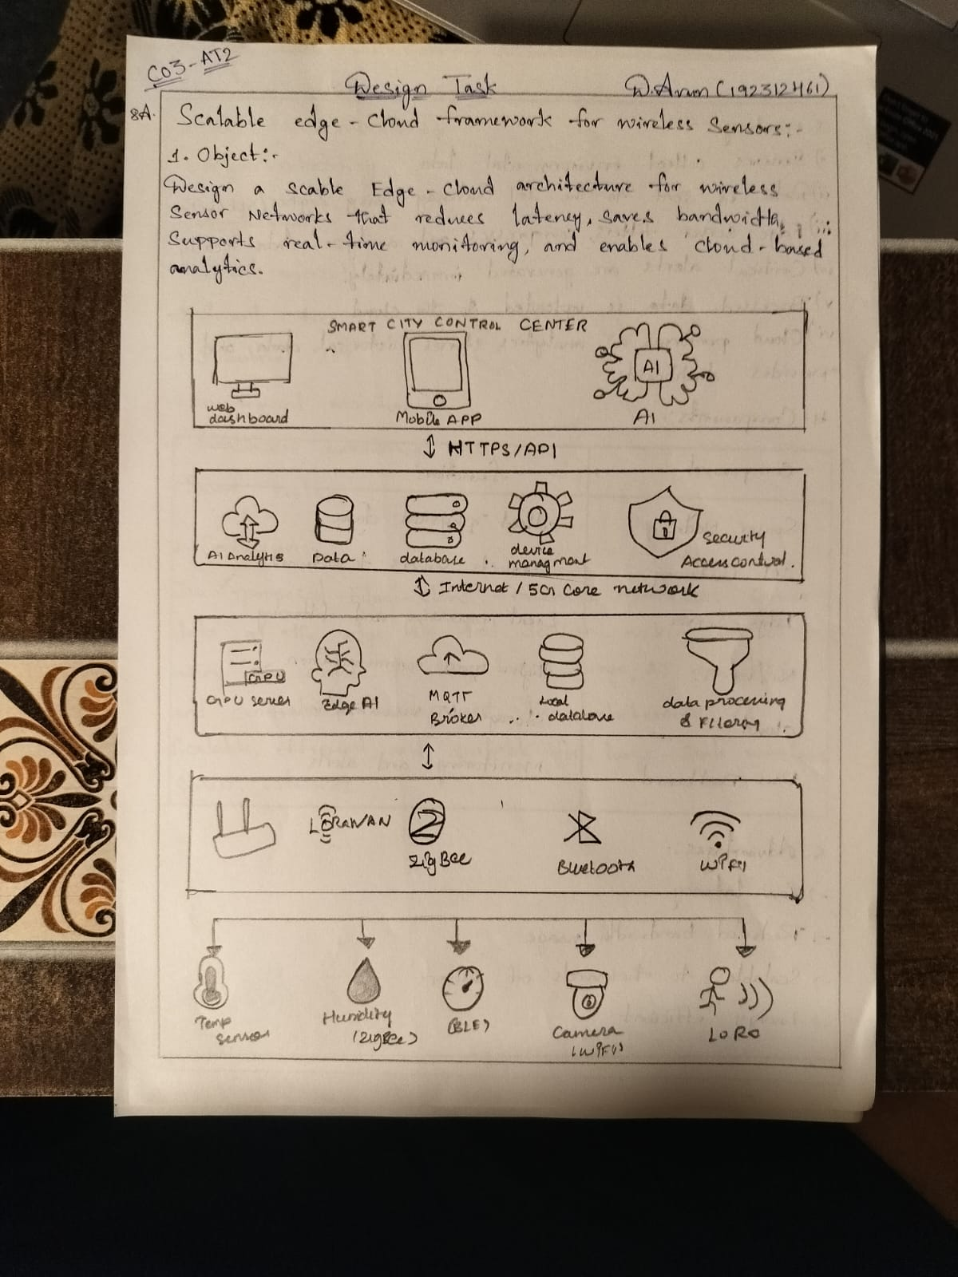

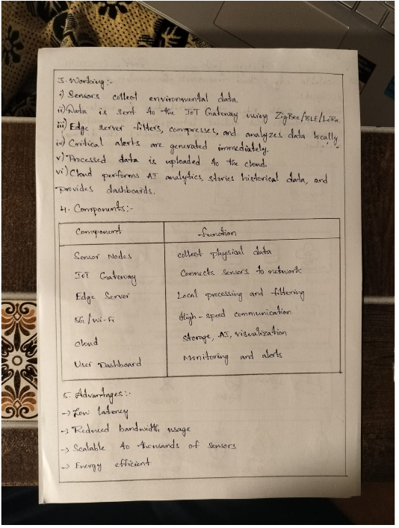

Code Implementation:
clc;
clear;
close all;

%% Parameters
numSensors = 100; % Number of sensor nodes
numEdges = 5; % Number of edge servers
packetSize = 512; % Bytes
simulationTime = 100; % Seconds

%% Random Sensor Data
sensorData = randi([10 100], numSensors, simulationTime);

%% Sensor to Edge Assignment
edgeAssignment = randi([1 numEdges], numSensors,1);

%% Initialize Variables
edgeProcessed = zeros(numEdges, simulationTime);
latency = zeros(numSensors, simulationTime);
energy = zeros(numSensors, simulationTime);

%% Edge Processing
for t = 1:simulationTime

for s = 1:numSensors

edge = edgeAssignment(s);

% Data aggregation at Edge
edgeProcessed(edge,t) = edgeProcessed(edge,t) + sensorData(s,t);

% Random latency (milliseconds)
latency(s,t) = 5 + rand()*5;

% Energy Consumption (Joules)
energy(s,t) = 0.001 * sensorData(s,t);

end

end

%% Cloud Receives Aggregated Data
cloudData = sum(edgeProcessed);

%% Performance Metrics
avgLatency = mean(latency(:));
avgEnergy = mean(energy(:));
throughput = sum(cloudData)/(simulationTime);

fprintf('Average Latency = %.2f ms\n',avgLatency);
fprintf('Average Energy = %.4f Joules\n',avgEnergy);
fprintf('Throughput = %.2f Bytes/sec\n',throughput);

%% Graphs

figure;
bar(sum(edgeProcessed,2))
xlabel('Edge Servers')
ylabel('Aggregated Data')
title('Data Processed by Edge Servers')
grid on

figure;
plot(mean(latency,1),'LineWidth',2)
xlabel('Time (s)')
ylabel('Latency (ms)')
title('Average Network Latency')
grid on

figure;
plot(mean(energy,1),'r','LineWidth',2)
xlabel('Time (s)')
ylabel('Energy (Joules)')
title('Average Energy Consumption')
grid on

figure;
plot(cloudData,'k','LineWidth',2)
xlabel('Time (s)')
ylabel('Data Sent to Cloud')
title('Cloud Throughput')
grid on

Output:

